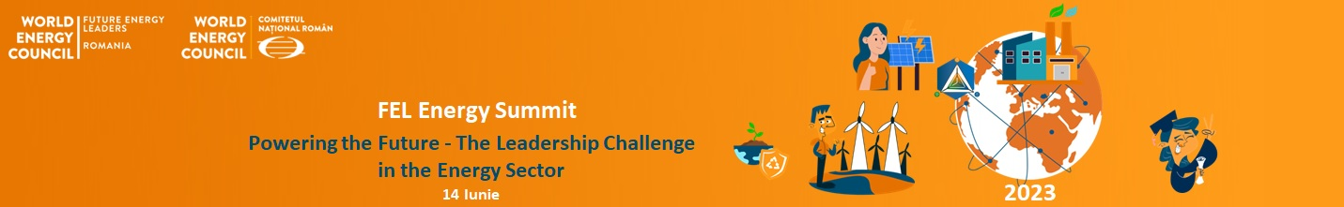
14th of June

Description of the event:

The energy sector is experiencing significant and rapid changes, and the leaders of the energy industry operate in an environment characterized by permanent changes, with a high degree of uncertainty regarding the future of the energy sector.

The volatility specific to the energy industry, questioning the efficiency of market mechanisms, legislative and fiscal challenges, geopolitical factors and environmental issues, are elements that exert enormous pressure on decision-makers. But we have the certainty of a European objective: climate neutrality in 2050.

In order to get overview of the current situation of the energy sector and the future role of young energy professionals in this sector, FEL Romania is organizing the FEL Energy Summit: Powering the Future – The Leadership Challenge in the Energy Sector.

In this context, the FEL Energy Summit aims to discuss and debate to what extent the decisions adopted today will contribute to the stability of the energy system, while remains aligned to the requirements of the European Green Deal, respectively what role can play the new generation of leaders in the energy sector.

By organizing this event, FEL Romania aims to identify the main problems and solutions to the current challenges of the Romanian energy sector, discussing topics like regulation, sustainability, price affordability, energy security, government priorities, but also how to prepare the future generations of energy leaders. The Summit also aims to create a bridge between the current and future generations of leaders in the energy sector.

Agenda
9:30 - 10:00 Welcome coffee
10:00 - 10:30 Opening session: Claudia Candale, Events & Partnerships Manager FEL România
- Claudia Candale, Events & Partnerships Manager FEL România
- Dan Ioan Gheorghiu, CNR-CME President

10:30 - 12:00 Panel 1 – Current status of the energy industry and where are we headed? Public Administration perspective

Moderator – Mihai Macarie, Romanian Energy Center & FEL Romania Alumnus

- Cristian Buşoi, Chair of the Committee on Industry, Research and Energy, European Parliament (online)
- Lorant Antal, Chair of Committee on Energy and Mineral Resources, Romanian Senate
- Sandor Bende, Chair of Committee on Services and Industry, Chamber of Deputies
- George Niculescu, President, National Energy Regulatory Authority (ANRE)
- Dan Drăgan, State Secretary, Ministry of Energy
- Alexandra Bocşe, Consilier de Stat State Counselor for Climate and Sustainability, The Presidential Administration

12:00 - 13:00 Lunch break
14th of June

13:00 - 14:45 Panel 2 - Challenges of energy transition according to WEC studies and monitoring of energy issues. How can leaders cope, as effectively as possible, with all the changes?

Keynote speaker: Virgil Muşatescu, CNR-CME

Moderator – Mihai Toader-Paști, Founder towards 0 & IntreVecini, FEL Romania Alumnus

- Ștefan Gheorghe, General Director, CNR –CME
- Ștefan Popescu, ex State Secretary in the Ministery of Foreing Affairs
- Radu Dudău, Executiv Director, Energy Policy Group (EPG)
- Cătălin Niţă, Executiv Director, FPPG
- Dumitru Chisăliţă, Executiv Director, Asociația Energia Inteligentă
- Suzana Carp, Specialist in European public policies & Deputy Executive Director Cleantech for Europe
- Sabina Strîmbovschi, Foreing Affairs Expert, FEL Romania

14:45 - 15:00 Coffee break

15:00 - 16:30 How do we prepare the future energy leaders?

Moderator – Claudiu Butacu, EfdeN President & FEL Romania Alumnus

- Michelle Arellano, Membership Manager - World Energy Council (online)
- Ștefăniţă Munteanu, CEO, Transelectrica
- Nicolas Richard, CEO, ENGIE Romania
- Mihaela Suciu, CEO, DEER
- Franck Neel – Board Member for Gas & Power, OMV Petrom
- Diana Robescu, Dean of the Faculty of Energy, Politehnica University of Bucharest
- Cătălina Nedelcu, MBA Energy program coordinator, FABIZ, Academy of Economic Studies
- Alisa Fleancu, Power Engineer, FEL Romania

16:30 - 16:45 Closing session

- Rareș Hurghiș, General Manager, FEL Romania
- Mădălina Nan, Project Manager FEL Energy Summit, FEL Romania

16:45 - 17:30 Networking

